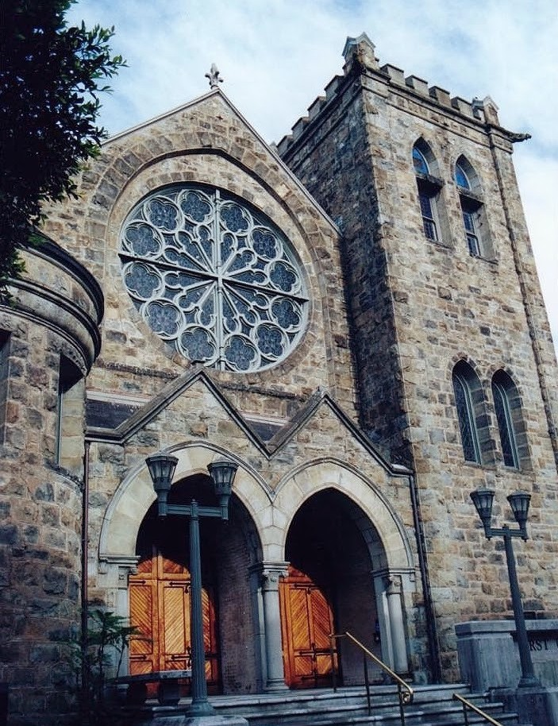Order of Service

First Unitarian Universalist Society of San Francisco

Order of Service 10:50 AM - 12:15 PM
Livestreamed at bit.ly/uusfmedia
New to UUSF? Complete Our Connections form at bit.ly/uusfconnections2022
Welcome back to those returning to onsite Worship Service!
Please stay masked during the Worship Service and maintain social distance.
After service we invite you to convene for coffee hour in the Courtyard.
As we ease back into the new normal, we want to keep our congregation and staff safe.
Please be mindful of social distance and wear your mask when you are not eating or drinking.

Prelude Welcome
*Hymn

Unison Chalice Lighting

Brief Invitations
We light this chalice for the light of truth, the warmth of love,
and the fire of commitment.
We light this symbol of our faith as we gather together.

2

Covenant
Love is the spirit of this church, and service is its prayer. This is our great covenant: to dwell together in peace, to seek the truth in freedom, and to help one another.

*Doxology TALLIS' CANON
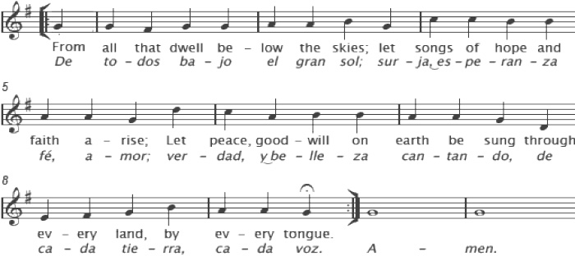

Ritual of Remembrance and Commitment

Time for Meditation and Prayer Music
Reflection/Reading

Offering
The offering today goes to support the work and ministries of the congregation. To make a donation on Vanco (bit.ly/uusfpayments)or using the Donate Button (below) & on our website, please select the “Offering” choice to make your gift. If you are sending a check, please mark in the memo today’s date and “special offering”.

DONATE

3

Offertory Music

Reading

Music/Hymn

Sermon

*Hymn

Benediction Postlude

*please stand if you are willing and able.

PARTICIPANTS

4

Events, Meetings & Volunteer Opportunities (www.uusf.org/news)

Morning Meta Meditation
Adult Spiritual Growth Classes (www.uusf.org/are)
Tuesdays & Thursday, 8-8:30 am (https://us04web.zoom.us/j/75735734442#success)
A simple, centering loving kindness meditation practice which is appropriate for all religious backgrounds and levels of meditation experience.

Equanimity Practice
Fridays, 8-8:30 am (https://us04web.zoom.us/j/75735734442#success)
A meditation practice on cultivating equanimity—that is, accepting the reality of life’s highs and lows and developing an attitude of peaceful calm abiding throughout the inevitable changes.

CLICK HERE TO VIEW OUR VIDEOS
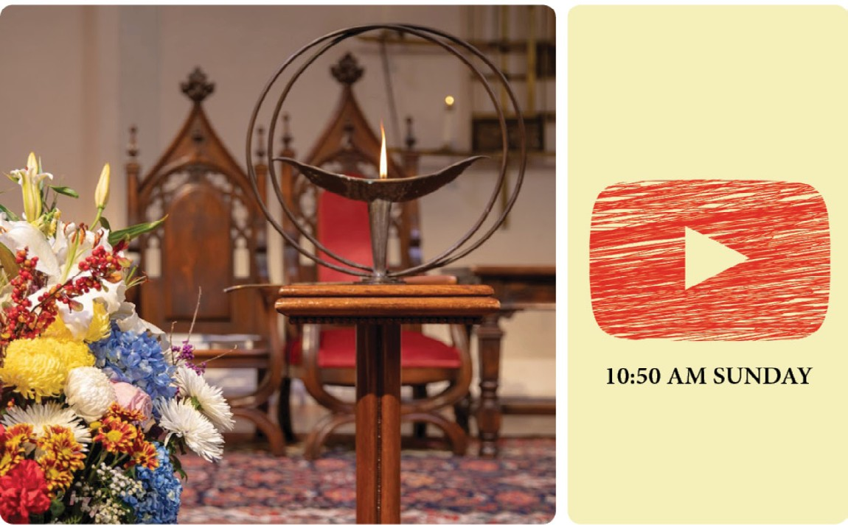

UUSF MEDIA
Listen to our Worship Sermon Podcasts Here
Check out our Complete Worship Service Archives Here View Our Videos Here
Check out our Website Here View UUSF News Here Contact us here

Welcome to the First Unitarian Universalist Society of San Francisco
ince its founding in 1850 our congregation has been a beacon of religious liberalism in this city. During the Civil War, the Rev. Thomas Starr King was credited with keeping California in the Union. He also challenged racism, raised millions for
S
humanitarian relief and inspired new efforts in education.

Unitarianism and Universalism in America both arose in New England during the American Revolution. Because the roots of both traditions are in the Judeo-Christian tradition, you will see on the walls of our sanctuary two inscriptions:
"What doth the Lord require of thee, but to do justly, to love mercy, and to walk humbly with your God?" (from the Hebrew prophet Micah) and “The Kingdom of God is within you.” (from the Gospels)

Our religious forebears were far more interested in the teaching examples of Jesus than in beliefs about Jesus. Today we agree more about how we strive to treat others than we do about beliefs. Our backgrounds and spiritual orientations are diverse. Among us are people who consider themselves atheists, agnostics, humanists, Christians, Jews, Buddhists, Muslims, Pagans and people guided by other forms of spirituality and belief.

Belief is many things, and so is disbelief. But we are interested in what happens to us when we open our minds to wider truth, our hearts to compassion, and our souls to the call to work for justice and peace.

OUR SOCIETY’S VISION
We, The First Unitarian Universalist Society of San Francisco, delight in our authentic, inclusive congregation that reaches across generations, ethnicities, and differences. We take care of one another, building spiritual community, knowing that we are stronger and accomplish more together. Guided by our responsibility to future generations, we take leadership in shaping a compassionate, sustainable world. Inspired by our courageous heritage and compelled by conscience, we hold one another accountable to work for racial, environmental, and economic justice and the dignity and rights of all.

OUR SOCIETY’S MISSION
As a vibrant, joyous, caring, inclusive community of diverse people, we create a nurturing space for spiritual growth and learning. Based on our shared values, we work together courageously and publicly for human rights, economic justice, and environmental salvation.

For more about our congregation, please visit our website at www.uusf.org.

First Unitarian Universalist Society of San Francisco 1187 Franklin Street, San Francisco, CA 94109
415-776-4580 / info@uusf.org

